**IFT598: Middleware Programming & Database Security**

Arizona State University

Assignment 4: ES6 Modern JavaScript

**Student**

Chih-Chieh Chang

**Professor**

Dinesh Sthapit

September 17, 2022

Req 1: Create a JavaScript Objects with the following properties + Req 2: Create an array of loans and add five instances of the above JavaScript objects based on the above specifications:

Code of loan.json

[

{

"id": 0,

"customerName": "John",

"phoneNumber": "4801112222",

"address": "751 E Bell Rd, Phoenix, AZ 85022",

"loanAmount": "250",

"interest": "0.06",

"loanTermYears" : "4",

"loanType": "Student Loan",

"description": "John is studying in ASU"

},

{

"id": 1,

"customerName": "Josh",

"phoneNumber": "4801121122",

"address": "3141 E Indian School Rd, Phoenix, AZ 85016",

"loanAmount": "500",

"interest": "0.1",

"loanTermYears" : "3",

"loanType": "Mortgage Loan",

"description": "Use for starting a new business"

},

{

"id": 2,

"customerName": "Joseph",

"phoneNumber": "4801221122",

"address": "507 W Thomas Rd, Phoenix, AZ 85013",

"loanAmount": "300",

"interest": "0.03",

"loanTermYears" : "1.5",

"loanType": "Auto Loan",

"description": "Used car"

},

{

"id": 3,

"customerName": "Joanna",

"phoneNumber": "4801112121",

"address": "1857 N Scottsdale Rd, Tempe, AZ 85281",

"loanAmount": "60",

"interest": "0.2",

"loanTermYears" : "1",

"loanType": "Payday Loan",

"description": "Critical"

},

{

"id": 4,

"customerName": "Joel",

"phoneNumber": "4801112211",

"address": "3603 E Indian School Rd, Phoenix, AZ 85018",

"loanAmount": "100",

"interest": "0.15",

"loanTermYears" : "5",

"loanType": "Home Equity Loan",

"description": "Investment use"

}

]

Screenshot of loan.json

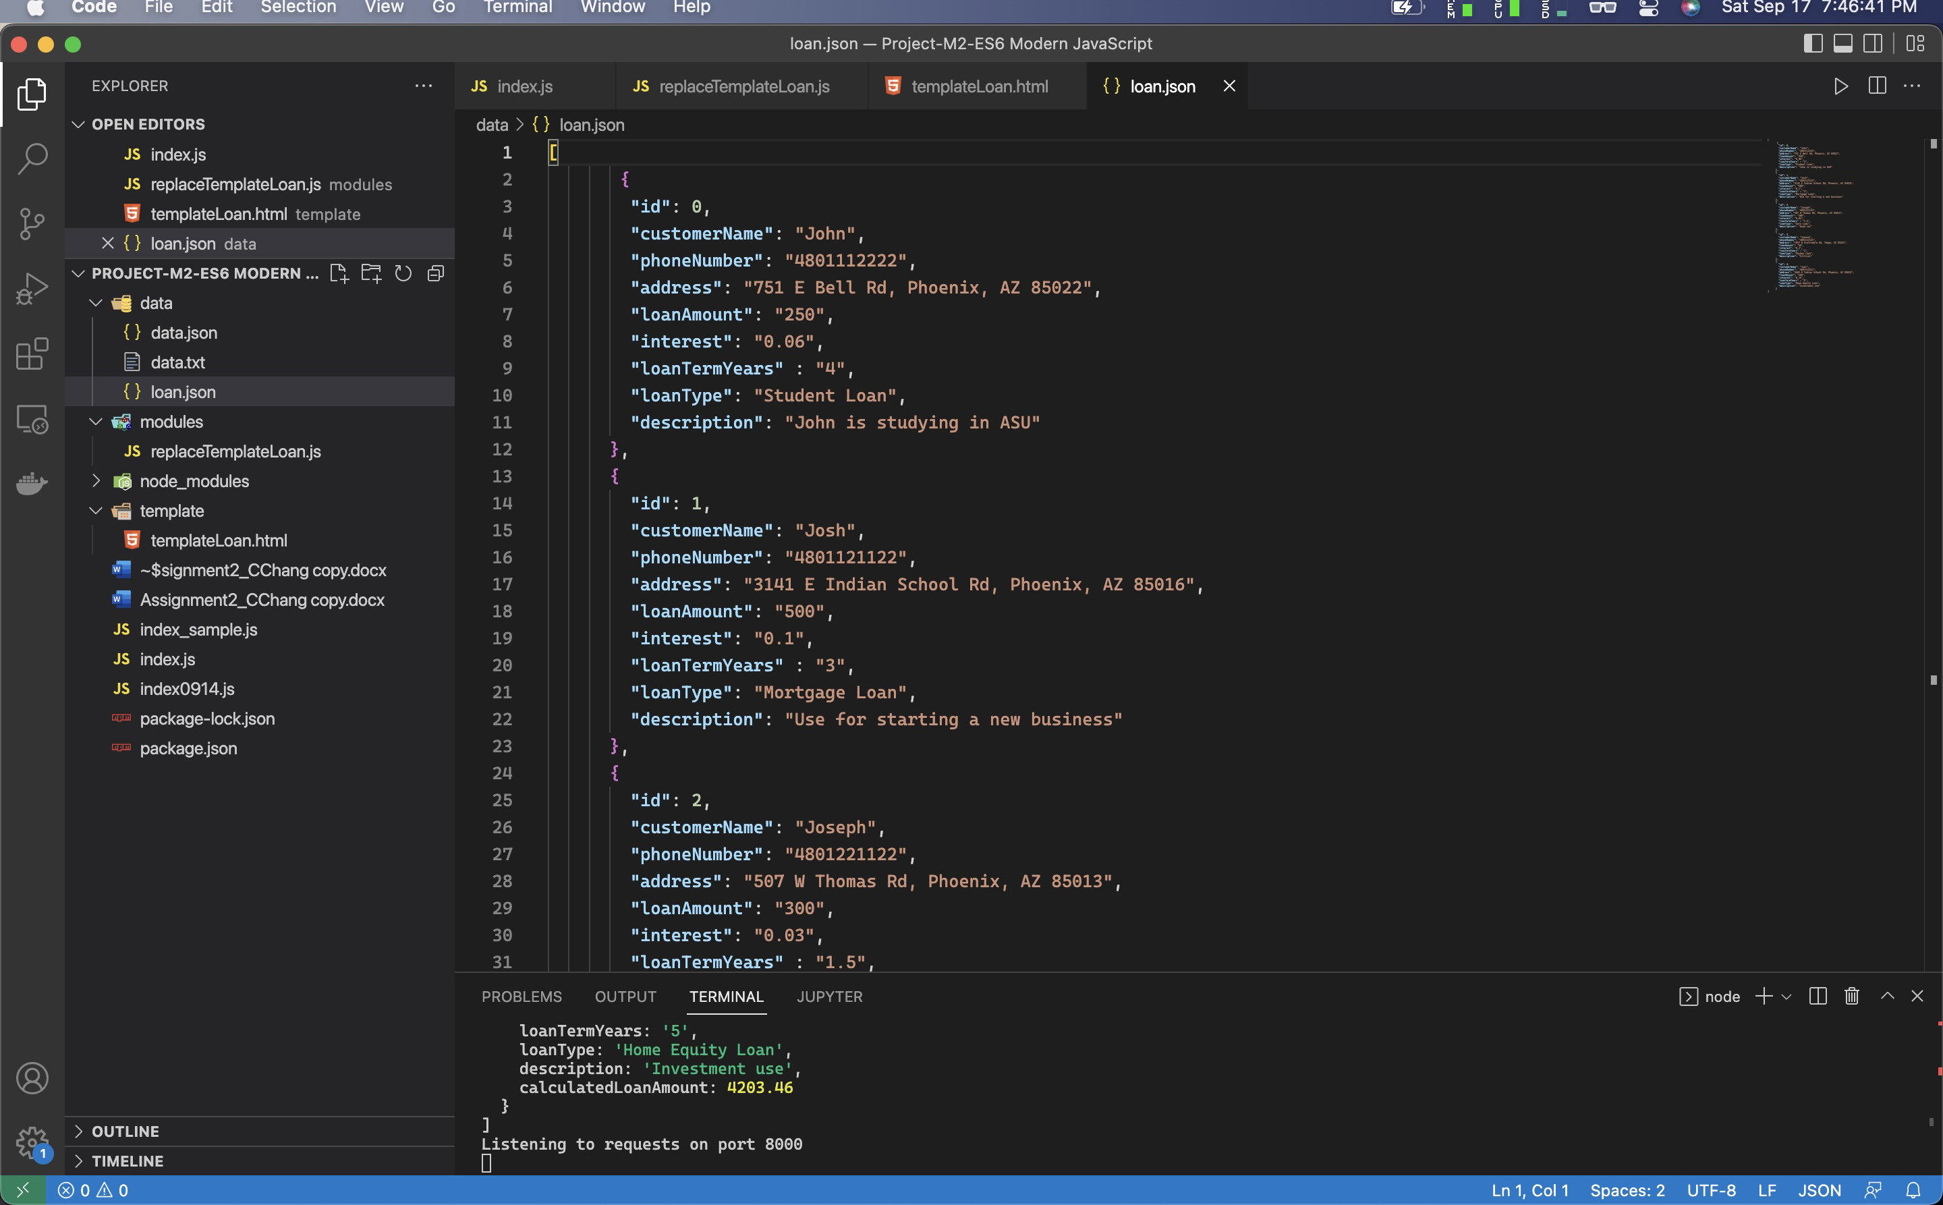

Code of templateLoan.html

<!DOCTYPE html>

<html lang="en">

<head>

<meta charset="UTF-8" />

<meta name="viewport" content="width=device-width, initial-scale=1.0" />

<meta http-equiv="X-UA-Compatible" content="ie=edge" />

<link

href="https://fonts.googleapis.com/css?family=Megrim|Nunito+Sans:400,900"

rel="stylesheet"

/>

<title>{%NAME%} /// Loan List</title>

<style>

html {

font-size: 62.5%;

box-sizing: border-box;

}

body {

padding: 5rem 5rem 5rem;

line-height: 1.7;

font-family: 'Nunito Sans', sans-serif;

color: rgb(85, 85, 85);

min-height: 100vh;

background: linear-gradient(to bottom right, #5d75e1, #4800e3);

}

h1 {

font-family: 'Megrim', sans-serif;

font-size: 6rem;

color: rgb(255, 255, 255);

text-align: center;

position: relative;

word-spacing: 3px;

}

.container {

width: 95rem;

margin: 0 auto;

}

.loan {

width: 60rem;

margin: 0 auto;

margin-top: 9rem;

background: white;

box-shadow: 0 3rem 6rem 1rem rgba(0, 0, 0, 0.2);

position: relative;

}

.loan__back:link,

.loan__back:visited {

position: absolute;

top: 2rem;

left: 2rem;

font-size: 1.5rem;

font-weight: 700;

text-transform: uppercase;

text-decoration: none;

z-index: 1000;

color: #555;

background-color: white;

box-shadow: 0 1rem 3rem rgba(0, 0, 0, 0.3);

border-radius: 100rem;

padding: 0 2rem;

transition: all 0.3s;

display: flex;

align-items: center;

}

.loan__back:hover,

.loan__back:active {

background-color: #79e17b;

}

.loan__name {

background: linear-gradient(to bottom, #9be15d, #00e3ae);

padding: 1rem;

font-family: 'Megrim', sans-serif;

font-size: 4rem;

color: white;

text-align: center;

word-spacing: 2px;

}

.loan__info {

padding: 2rem 2rem;

font-size: 1.6rem;

line-height: 1.8;

}

.loan__link:link,

.loan__link:visited {

display: block;

background-color: #79e17b;

color: white;

font-size: 1.6rem;

font-weight: 700;

text-transform: uppercase;

text-decoration: none;

padding: 1.5rem;

text-align: center;

transform: scale(1.07) skewX(-20deg);

box-shadow: 0 2rem 6rem rgba(0, 0, 0, 0.2);

display: flex;

align-items: center;

justify-content: center;

transition: all 0.3s;

}

.emoji-left {

font-size: 2rem;

margin-right: 1rem;

}

.emoji-right {

font-size: 2rem;

margin-left: 1rem;

}

</style>

</head>

<body>

<div class="container">

<h1>💸 Loan List 💸</h1>

<figure class="loan">

<a href="/" class="loan__back">

<span class="emoji-left">👈 Back </span>

</a>

<h2 class="loan__name">{%NAME%}</h2>

<div class="loan__info">

<p><span class="emoji-left">🗞 Phone Number: {%PHONENUMBER%} </span></p>

</div>

<div class="loan__info">

<span class="emoji-left">💸 Loan Type: {%LOANTYPE%}</span>

</div>

<div class="loan__info">

<span class="emoji-left">🎓 Description: {%DESCRIPTION%} </span>

</div>

<div class="loan__info">

<span class="emoji-left">🏬 Address: {%ADDRESS%} </span>

</div>

<div class="loan__info">

<span class="emoji-left">💸 Monthlt Loan Payment: {%MONTHLYLOANAMOUNT%}</span>

</div>

<div class="loan__info">

<span class="emoji-left">💸 Interest Rate: {%INTEREST%}</span>

</div>

<div class="loan__info">

<span class="emoji-left">💸 Years of Loan Term: {%LOANTERMYEARS%}</span>

</div>

<div class="loan__info">

<span class="emoji-left">💸 Total Amount of Loan: {%LOANCALCULATE%}</span>

</div>

</figure>

</div>

</body>

</html>

Screenshot of templateLoan.html

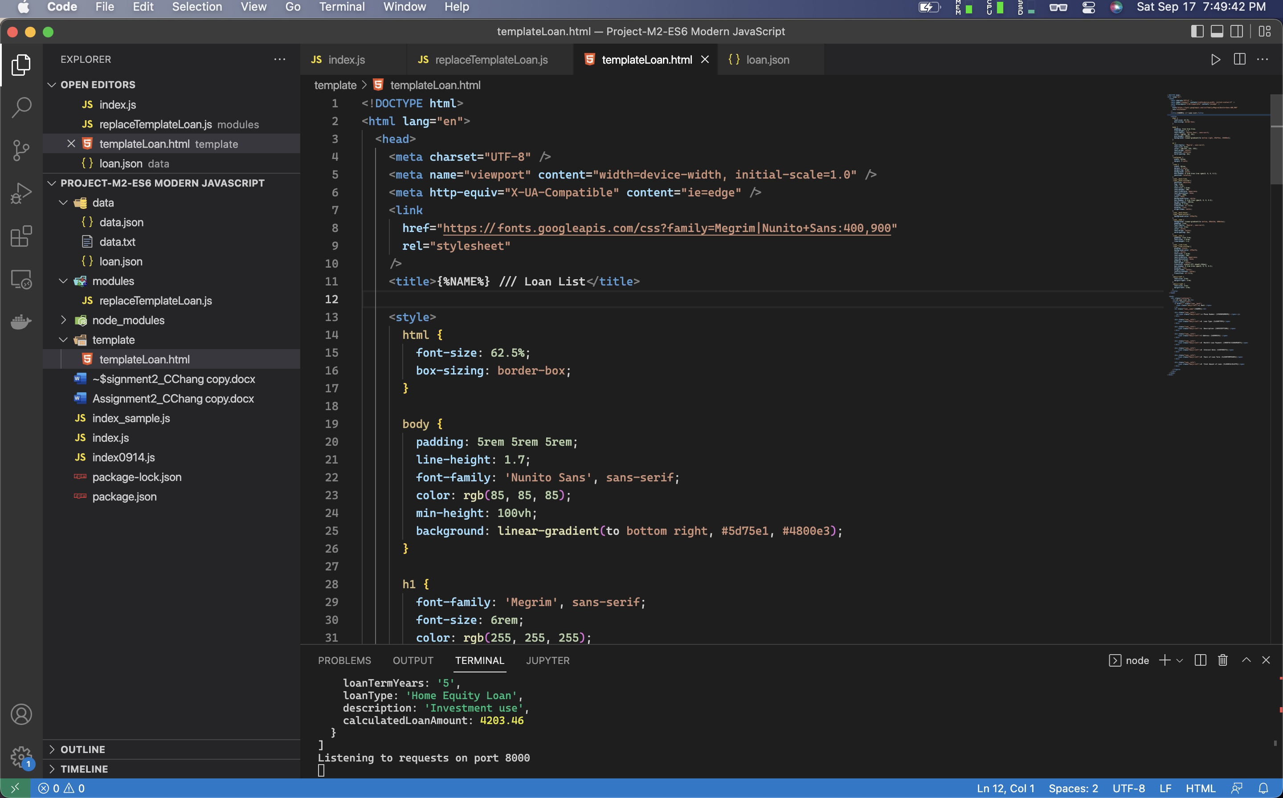

Req 3: List all the array elements with the grand total loan amount using console.log statements.

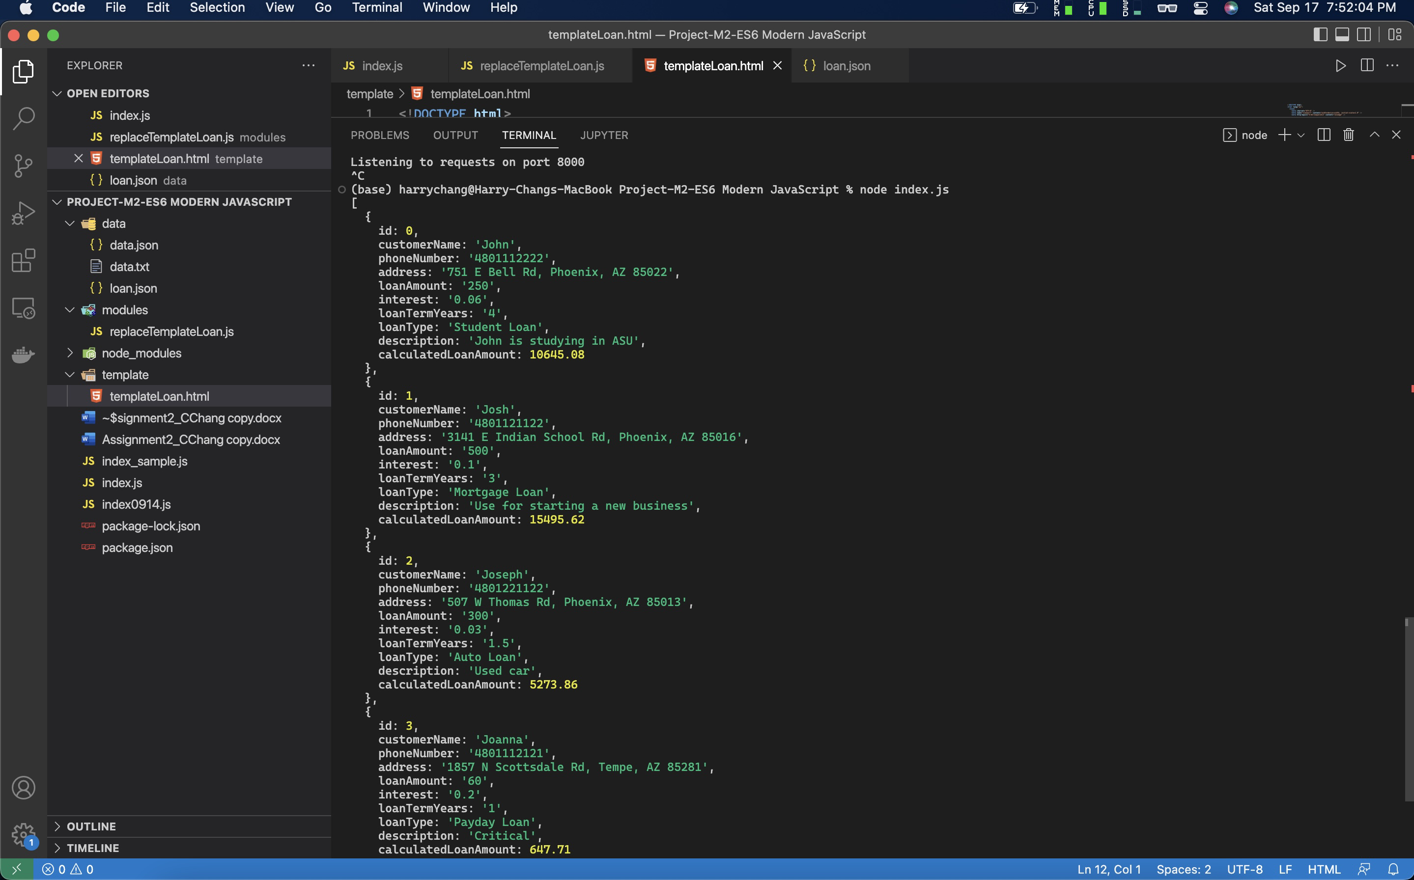

Screenshot of index.js:

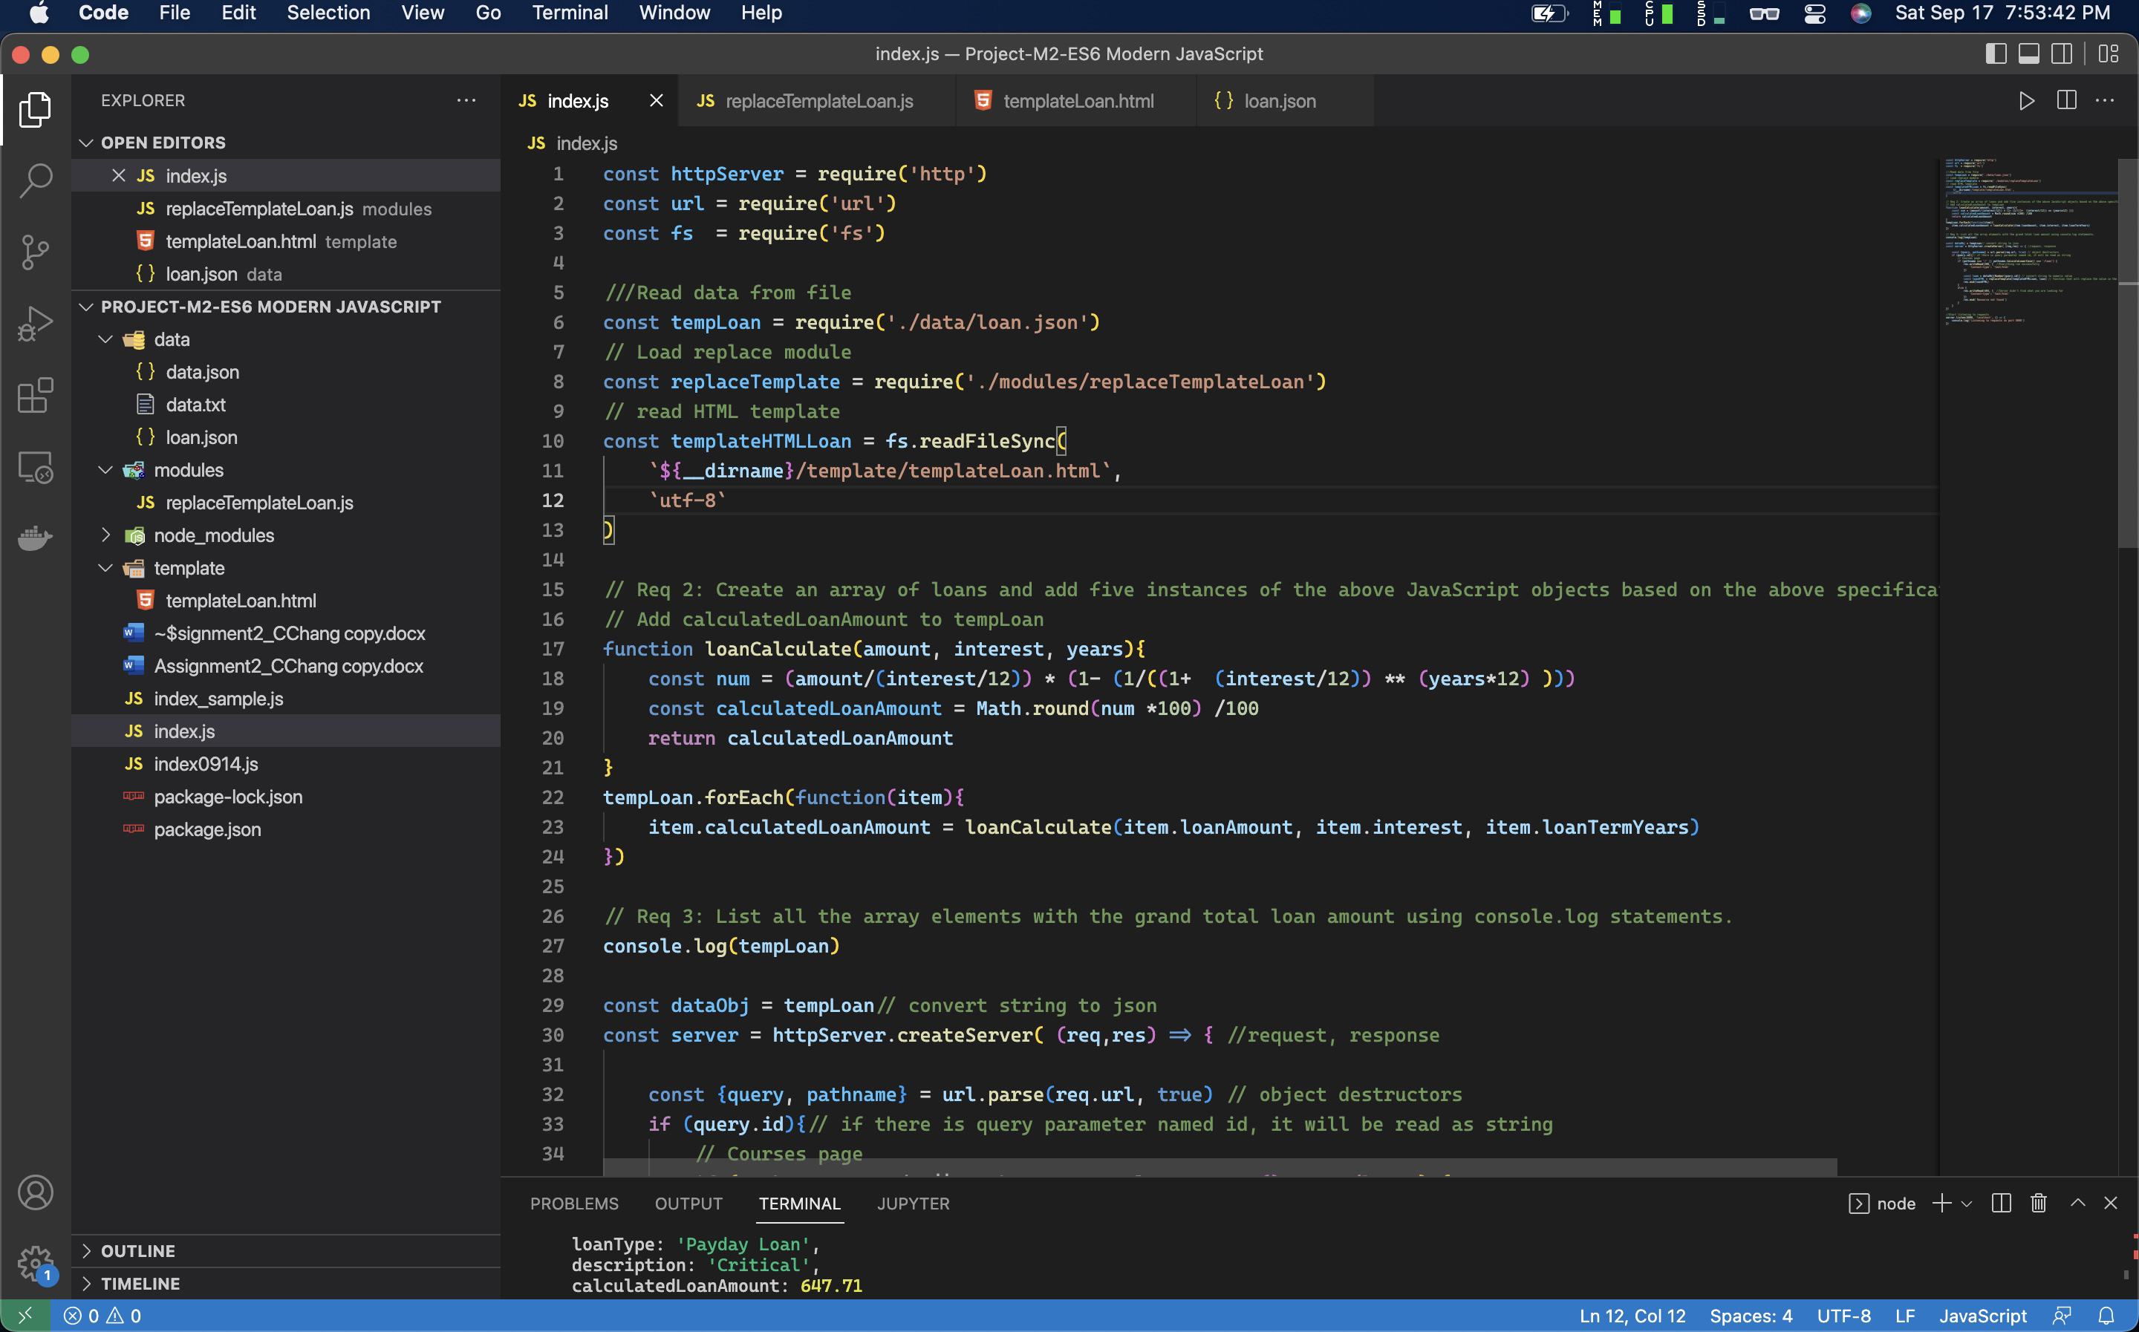

Code of index.js:

const httpServer = require('http')

const url = require('url')

const fs = require('fs')

///Read data from file

const tempLoan = require('./data/loan.json')

// Load replace module

const replaceTemplate = require('./modules/replaceTemplateLoan')

// read HTML template

const templateHTMLLoan = fs.readFileSync(

`${__dirname}/template/templateLoan.html`,

`utf-8`

)

// Req 2: Create an array of loans and add five instances of the above JavaScript objects based on the above specifications

// Add calculatedLoanAmount to tempLoan

function loanCalculate(amount, interest, years){

const num = (amount/(interest/12)) * (1- (1/((1+ (interest/12)) ** (years*12) )))

const calculatedLoanAmount = Math.round(num *100) /100

return calculatedLoanAmount

}

tempLoan.forEach(function(item){

item.calculatedLoanAmount = loanCalculate(item.loanAmount, item.interest, item.loanTermYears)

})

// Req 3: List all the array elements with the grand total loan amount using console.log statements.

console.log(tempLoan)

const dataObj = tempLoan// convert string to json

const server = httpServer.createServer( (req,res) => { //request, response

const {query, pathname} = url.parse(req.url, true) // object destructors

if (query.id){// if there is query parameter named id, it will be read as string

// Courses page

if (pathname === '/' || pathname.toLocaleLowerCase() === '/loan') {

res.writeHead(200, { //Everything run successfully

'Content-type': 'text/html'

})

const loan = dataObj[Number(query.id)] // convert string to numeric value

const loanHTML = replaceTemplate(templateHTMLLoan, loan) // function that will replace the value in the HTML

res.end(loanHTML)

}

else {

res.writeHead(404, { //Server didn't find what you are looking for

'Content-type': 'text/html'

})

res.end(`Resource not found`)

}

}

})

//Start listening to requests

server.listen(8000, 'localhost', () => {

console.log('Listening to requests on port 8000')

})

Screenshot of templateLoan.html:

Screenshot of replaceTemplateLoan.html:

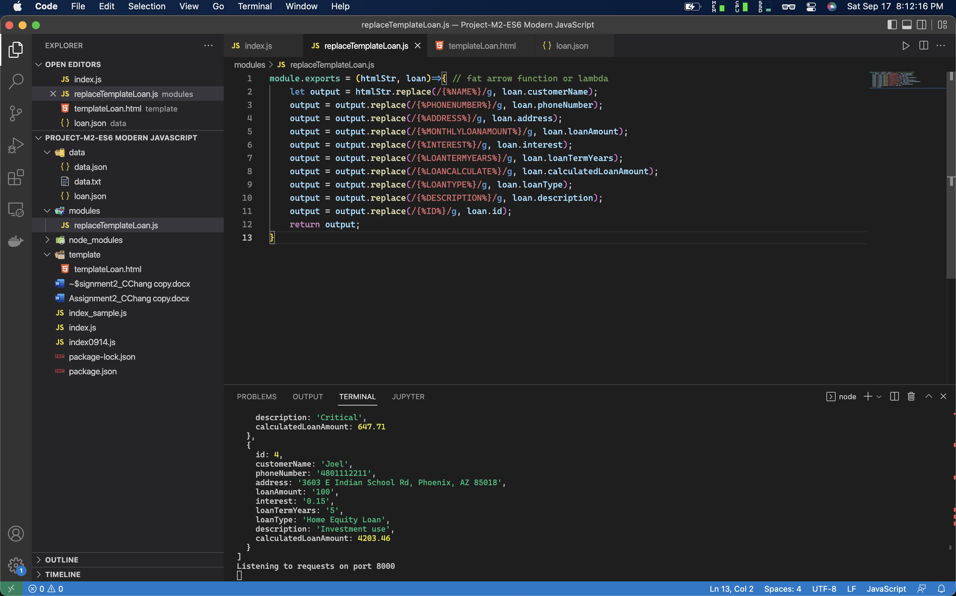

Code of replaceTemplateLoan.html:

module.exports = (htmlStr, loan)=>{ // fat arrow function or lambda

let output = htmlStr.replace(/{%NAME%}/g, loan.customerName);

output = output.replace(/{%PHONENUMBER%}/g, loan.phoneNumber);

output = output.replace(/{%ADDRESS%}/g, loan.address);

output = output.replace(/{%MONTHLYLOANAMOUNT%}/g, loan.loanAmount);

output = output.replace(/{%INTEREST%}/g, loan.interest);

output = output.replace(/{%LOANTERMYEARS%}/g, loan.loanTermYears);

output = output.replace(/{%LOANCALCULATE%}/g, loan.calculatedLoanAmount);

output = output.replace(/{%LOANTYPE%}/g, loan.loanType);

output = output.replace(/{%DESCRIPTION%}/g, loan.description);

output = output.replace(/{%ID%}/g, loan.id);

return output;

}

Displayed UI

* /loan?id=0

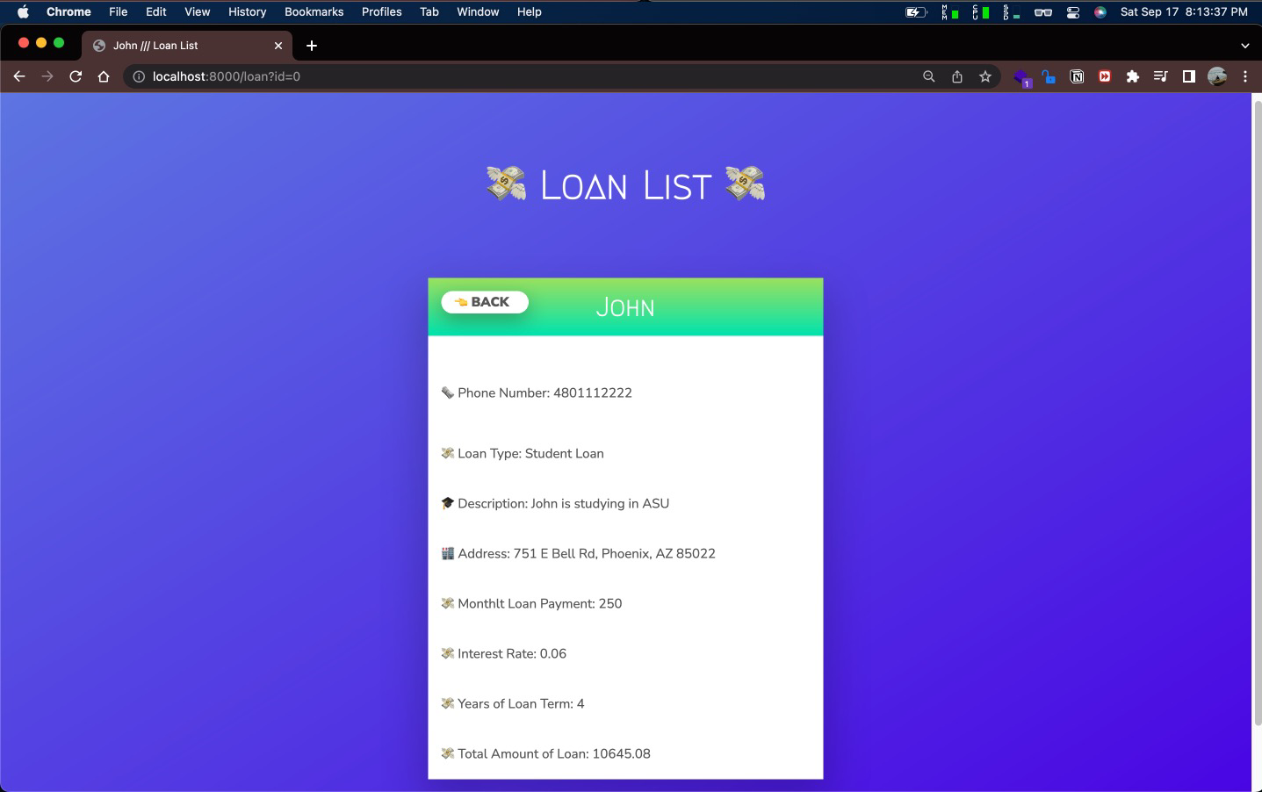

* /loan?id=1

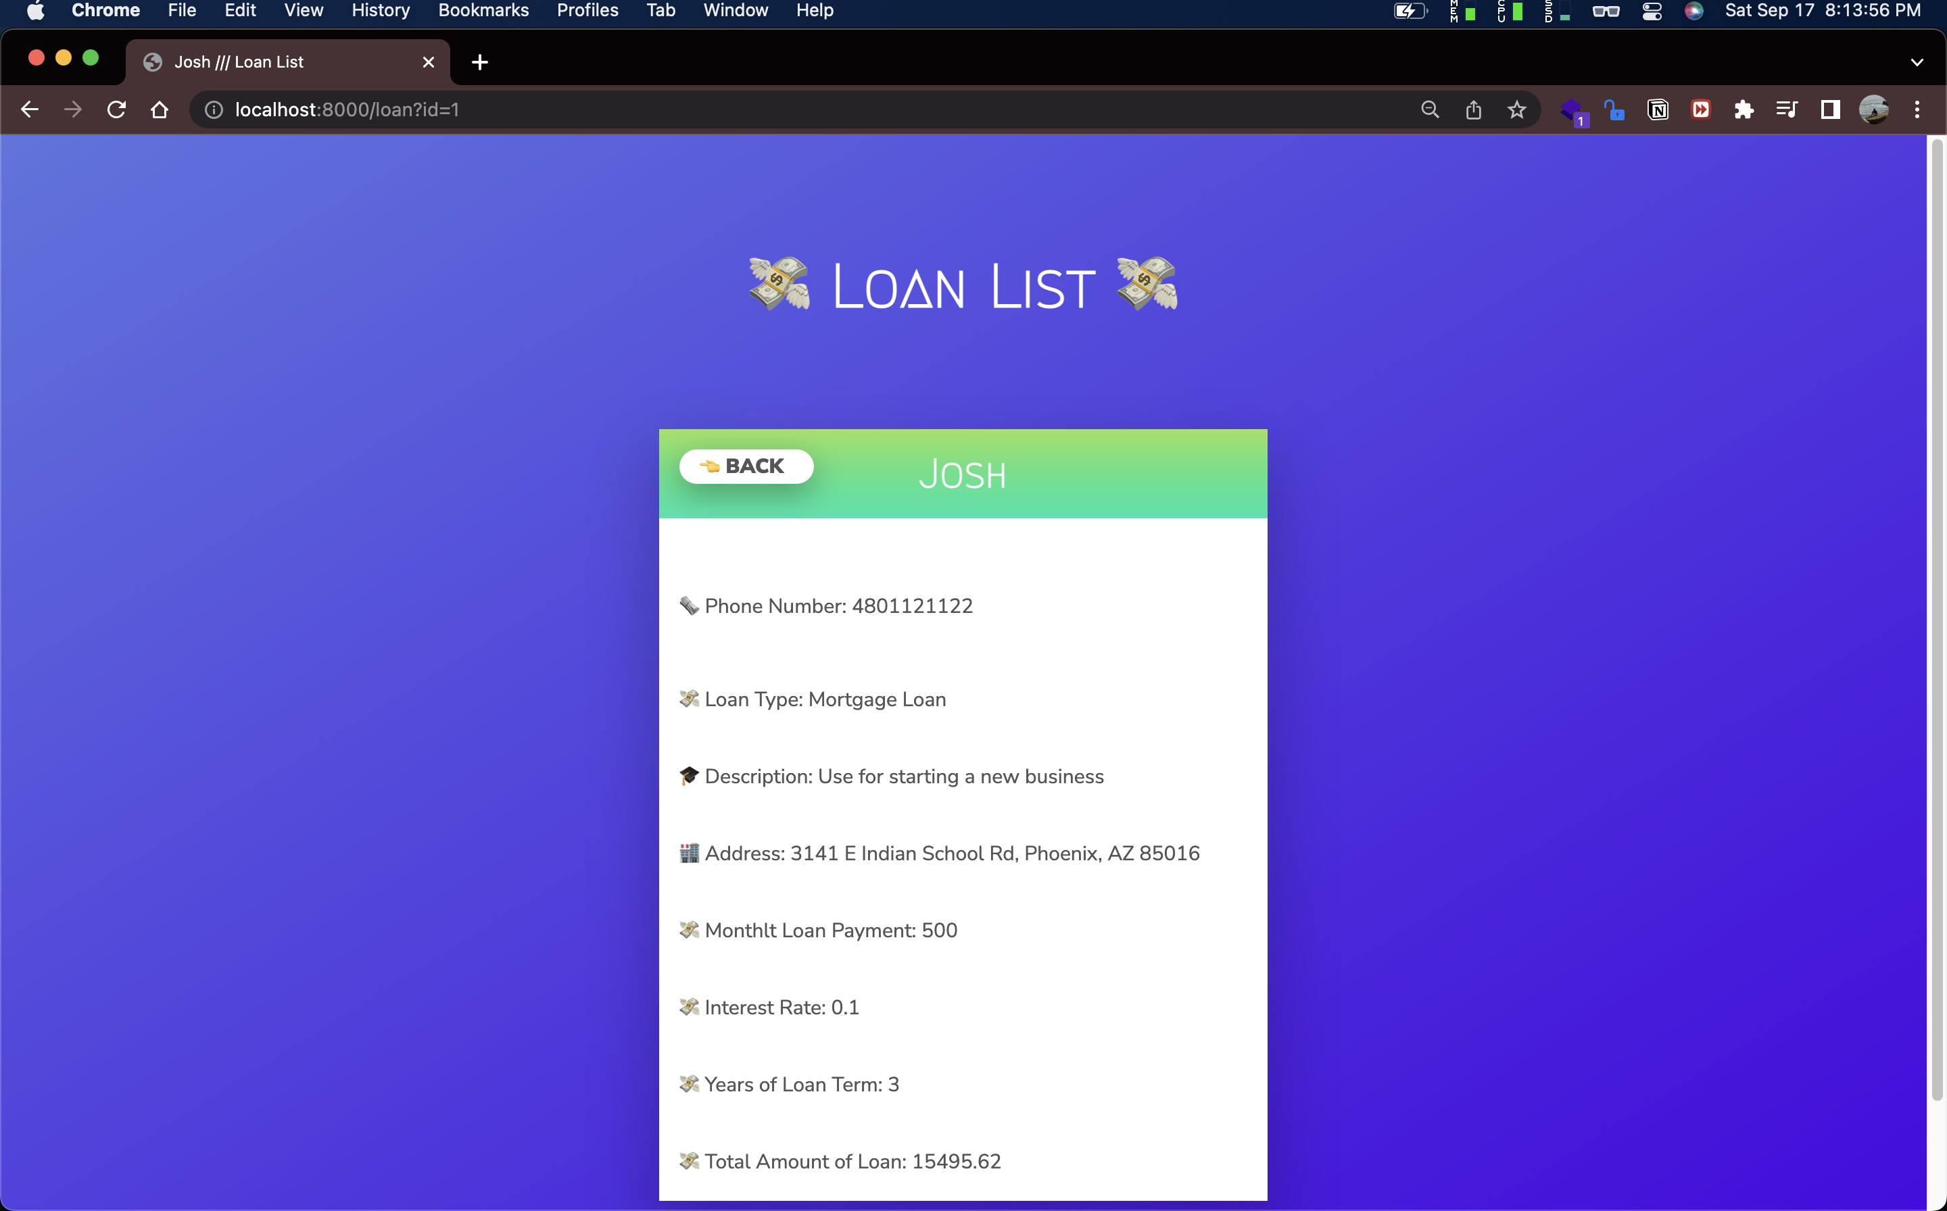

* /loan?id=2

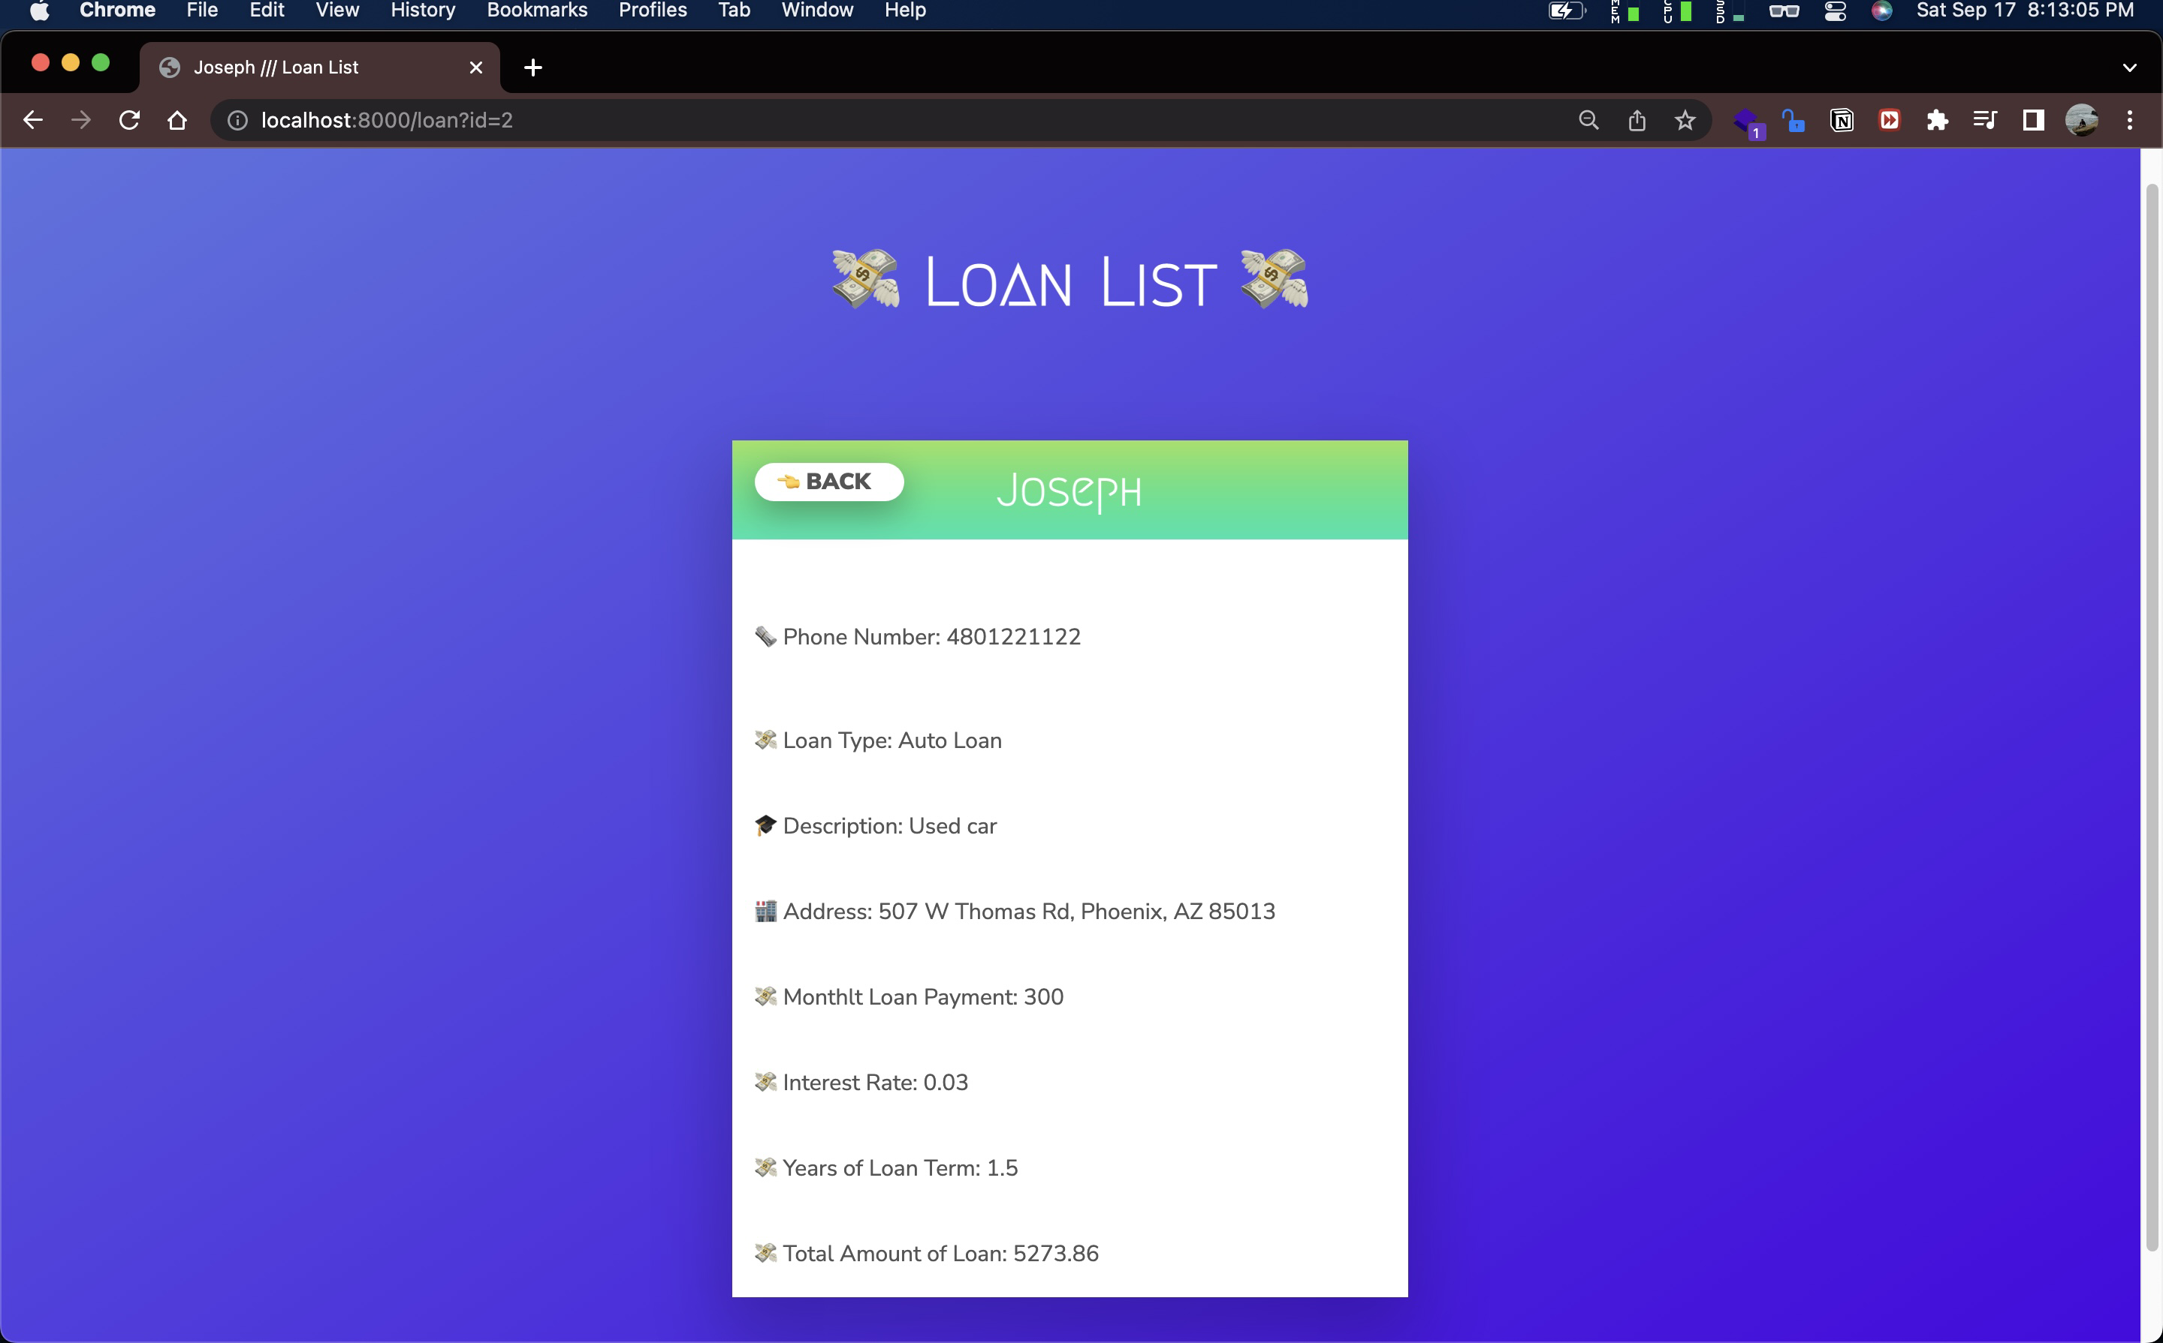

* /loan?id=3

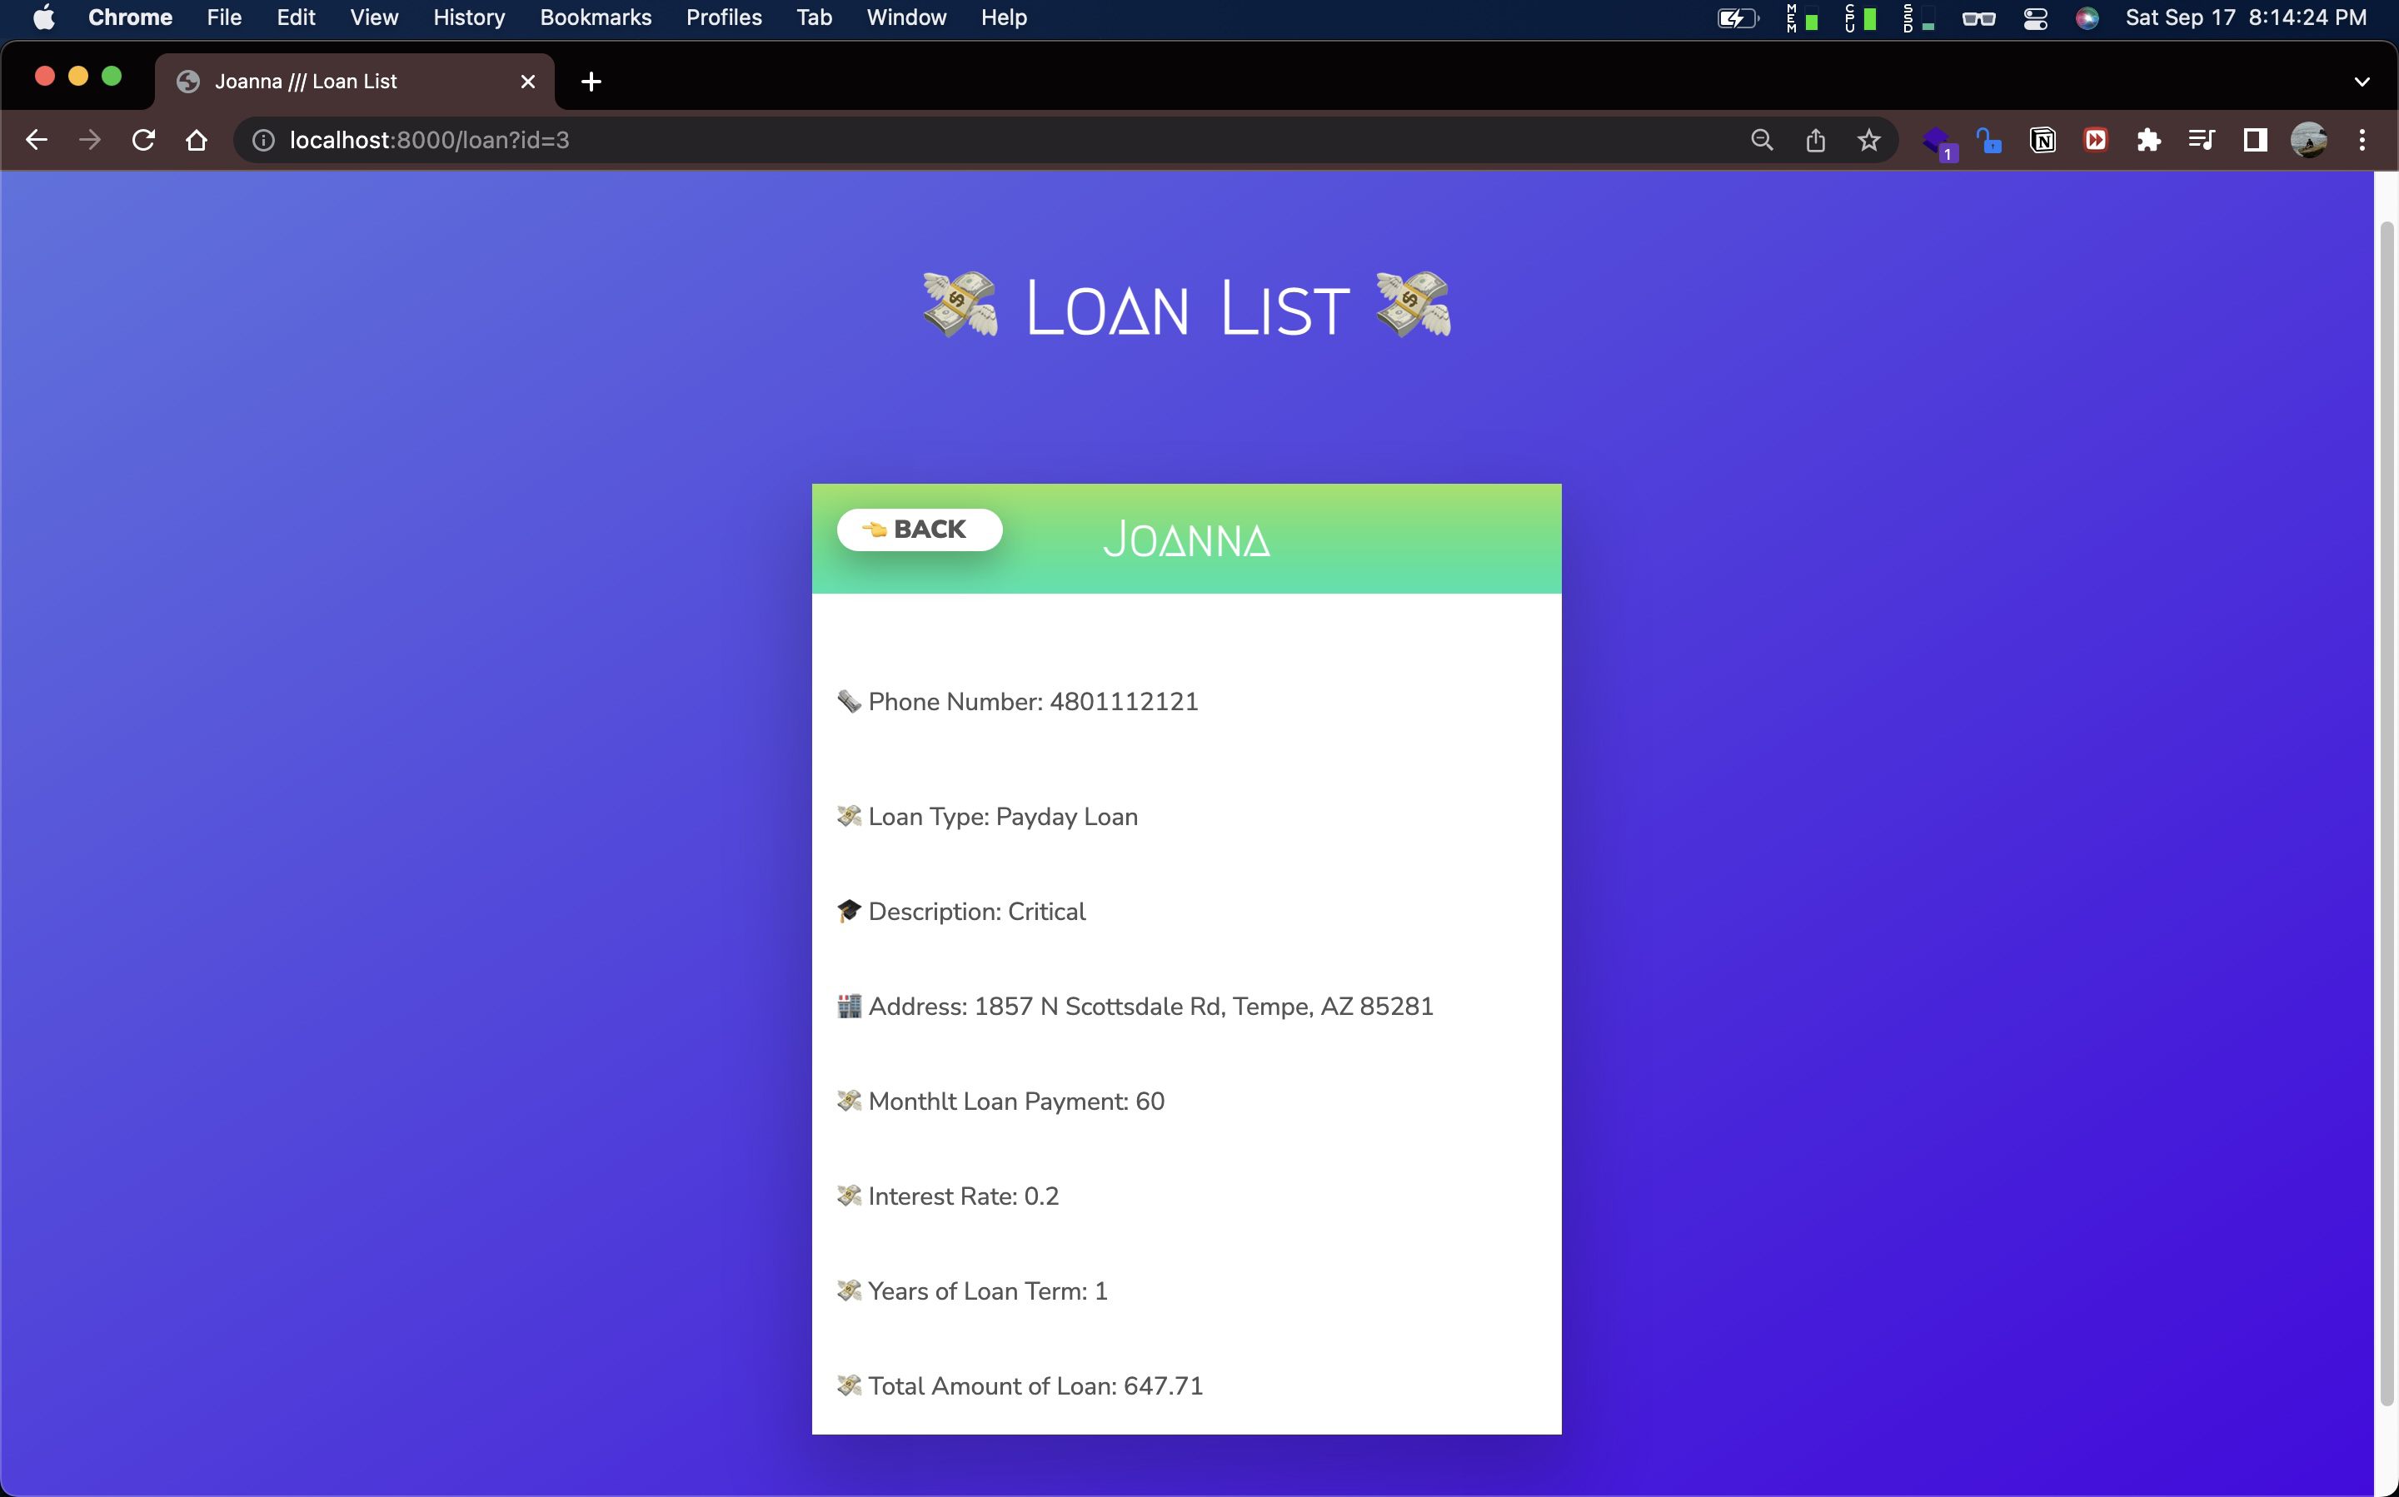

* /loan?id=4

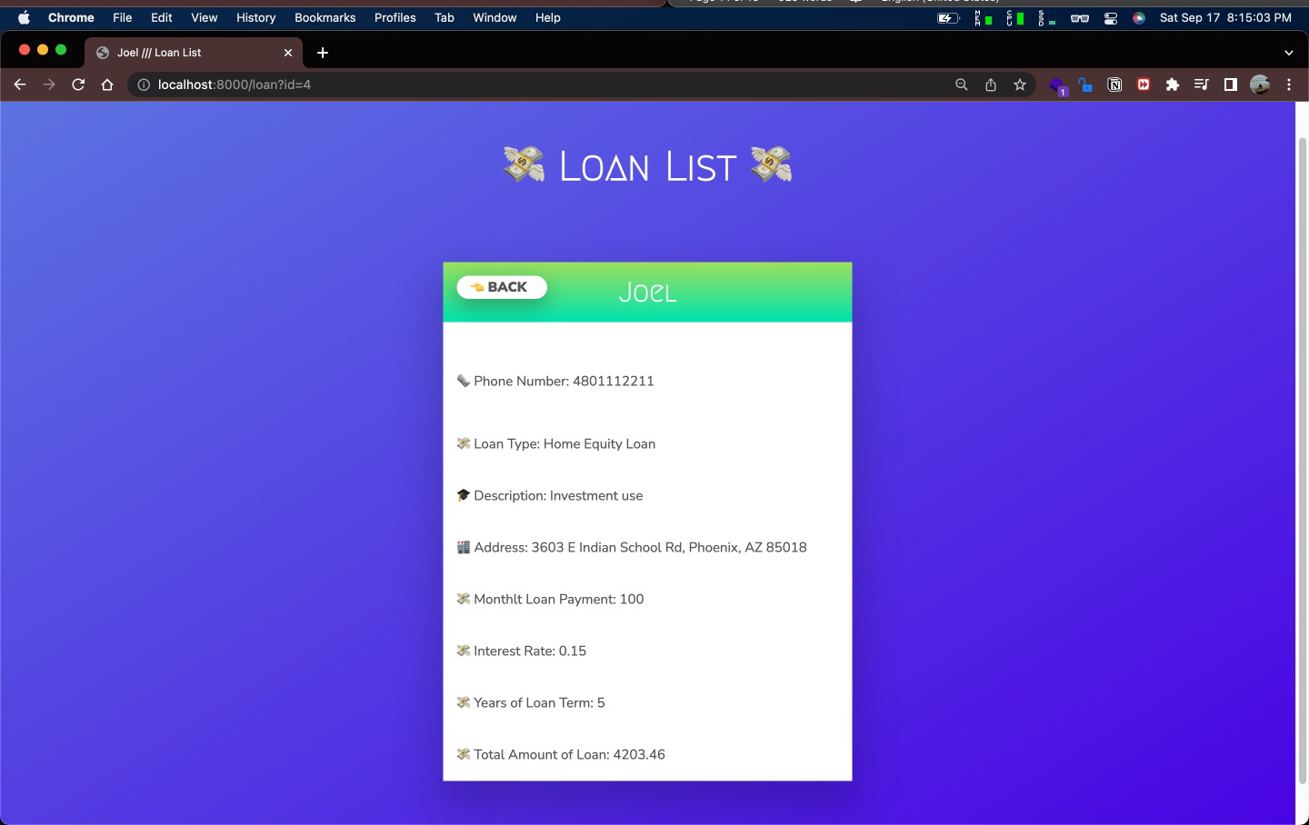

**References:**

REST API Tutorial (N.A.) HTTP Status Codes

<https://www.restapitutorial.com/httpstatuscodes.html>

Mdn web docs. (2022 July 3). HTTP response status codes. mdn.

<https://developer.mozilla.org/en-US/docs/Web/HTTP/Status>

Mdn web docs. (2022 Aug 29). Response header. mdn.

<https://developer.mozilla.org/en-US/docs/Glossary/Response_header>